COMMON COURSE ASSIGNMENT FORMAT

Assignment Information

Particular | Details
Department: | AIML
Programme: | B.Tech – Computer Science and Engineering (Artificial Intelligence and Machine Learning )
Course Code & Course Name | CSA1613 – Data Warehousing and Data Mining
Academic Year / Batch | 2025
Faculty Name | Kanimozhi K.V
Assignment Title | E-Commerce Data Warehouse and Customer Churn Prediction System
Date of Issue | AUGUST 31
Date of Submission | SEPTEMBER 2
Maximum Marks | 100
Course Outcome(s) – CO | CO1: Design data warehouse architectures with appropriate dimensional models for effective decision support systems.  CO2: Apply suitable data preprocessing techniques such as data cleaning, data integration, data transformation and data reduction for effective data preparation.  CO3: Evaluate the effectiveness of classification techniques on real-time data for accurate prediction and informed decision-making.
Bloom's Taxonomy Level | L3 – Apply, L4 – Analyze, L5 – Evaluate, L6 – Create
SDG Mapping (SDG 1-17) | SDG 8 – Decent Work and Economic Growth  SDG 9 – Industry, Innovation and Infrastructure  SDG 12 – Responsible Consumption and Production
Industry / Societal Relevance | It enables e-commerce businesses to combine their business information, comprehend the buying pattern of customers, recognize sales patterns, and even predict customers who are likely to switch over to other companies.

Assignment Problem / Challenge
E-Commerce Data Warehouse and Customer Churn Prediction
The database concerning customer information, order details, products, payment methods, deliveries, and other customer interactions on the website is maintained by the company. The management needs to understand the customer behavior in order to identify the customers who will stop using their services.
Design, develop, analyze, and evaluate the integrated solution for Data Warehousing and Data Mining which should:
- Combine the data about customers, orders, products, payments, and interactions.
- Create the star schema or snowflake schema.
- Develop the end-to-end ETL process.
- Apply appropriate preprocessing techniques.
- Perform Roll-up, Drill-down, Slice, Dice, and Pivot operations.
Determine:
- Best Selling Products
- Customer Segments
- Seasonal Trends
- Regional Performance
- High Value Customers
- Develop classification models for Customer Churn Prediction.
- Compare Decision Tree, Naïve Bayes, and SVM.
- Evaluate the models using classification metrics.
- Propose the customer retention strategy

Problem Statement

Problem Statement
An e-commerce company gathers data about customers orders, products, payments, delivery and website activity from systems. Because the data is in places it is hard to see how customers behave and how the business is doing overall.

The company wants a Data Warehouse that brings all these data sources together. This system will help analyze things like which products sell the most, which groups of customers buy the most, how sales change with the seasons how different regions do and which customers are the most valuable. The company also wants to find customers who might stop using the service.

The project builds a Data Warehousing and Data Mining system. It will combine data prepare it do analysis and predict which customers might leave. Techniques used include ETL, preprocessing. Analysis and models like Decision Tree, Naïve Bayes and Support Vector Machine (SVM).

Problem Formulation
The problem is about taking e-commerce data from sources and turning it into useful information for analysis and prediction. The data will be brought together through an ETL process. Arranged with the right Data Warehouse structure. OLAP tools like Roll-up Drill-down, Slice, Dice and Pivot will help analyze the data in ways.
For predicting churn features like customer and transaction details will be used. The target is whether the customer leaves or not. Models like Decision Tree, Naïve Bayes and SVM will be. Checked using Accuracy, Precision, Recall, F1-score, Confusion Matrix and Cross-validation.

Assumptions
- The data has details for analysis.
- Customer records can be connected with identifiers.
- Whether a customer. Not is known or can be found.
- Old data is good enough to build prediction models.

Requirements and Constraints

Requirements
The proposed system shall meet the following requirements:
- Integration of data from customers, orders, products, payments, deliveries and website interactions.
- Development of a full-fledged ETL (Extract, Transform and Load) operation.
- Data Preprocessing involving cleaning, integration, transformation and reduction.
- Designing the Star or Snowflake Schema of Data Warehouse.
- Performing OLAP operations which include Roll-up, Drill-down, Slice, Dice and Pivot.
- Analysis of best selling products, customer segments, sales by season, regional sales and best customers.
- Customer Churn Prediction models based on Decision Tree, Naïve Bayes and SVM.
- Model evaluation using appropriate classification metrics.
- Giving customer retention recommendations as per the result of analysis.
Constraints:
The following constraints shall be kept in mind in this project:
- Quality and availability of the dataset may influence the analysis and prediction process.
- Handling of missing values, duplicates, inconsistencies and outliers in pre-processing step.
- Computational resources and implementation time available limit this project.
- Performance of the model depends on the quality, size and features of available dataset.
1. PROBLEM UNDERSTANDING AND FORMULATION
As per the given problem, it is required to design an integrated system to analyse e-commerce data and predict customer churn. An e-commerce firm captures customer, orders, product, payment, delivery, and web interaction data through various sources. As the data is scattered among various operational systems, it is required to integrate the data before performing any analysis on it.
The result expected to be obtained after solving the problem is designing a Data Warehouse which will support multi-dimensional analysis to get various insights such as popular selling items, customer segments, seasonality in sales, regional performance, and high value customers. In addition, there is a requirement to develop classification models to predict the churned customers.
For Customer Churn Prediction, the attributes related to the customers and transactions will be taken as input features whereas the churn status will be taken as target variable. Decision Tree, Naïve Bayes, and SVM will be designed and compared.

Assumptions
- The existing dataset is adequate for doing business analytics and predicting churn.
- It is possible to match customers’ and transactions’ information with appropriate identifiers.
- There is either churn status present or one may calculate it from the existing information.
- Sufficient historical data is available for creating prediction models.
- Constraints That Should Be Met
- Data quality problems should be solved via preprocessing.
- The solution is expected to run under limited time and computational constraints.
- Customer information should be treated considering privacy, fairness, and ethical issues.
- The suggested solution is supposed to meet both analytic and predictive needs.

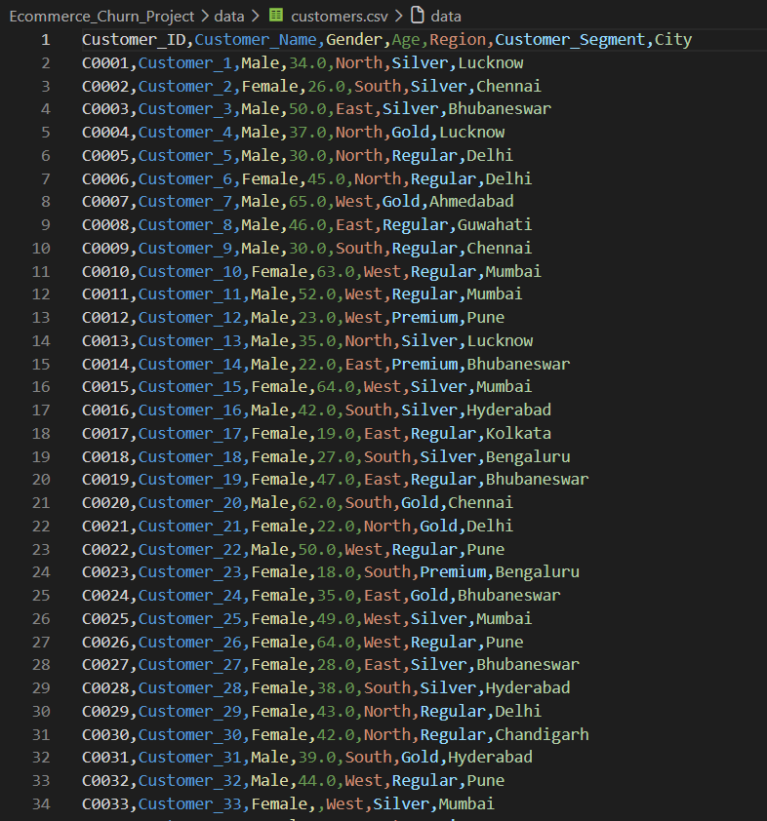

Application of Course Knowledge

The proposed solution implements the concepts of Data Warehousing and Data Mining course to solve the e-commerce business problem.
Data Warehousing
Data Warehouse integrates data from different operational databases into a central structure for performing analysis and decision-making. A suitable Star Schema or Snowflake Schema
ETL Process
The ETL process will be adopted to extract data from various sources, transform them into the appropriate format and load them into the Data Warehouse.
Data Preprocessing
Various data preprocessing techniques will be used to enhance data quality. This will involve:
- Data cleaning
- Data integration
- Data transformation
- Data reduction
- Dealing with missing values
- Dealing with duplicates
- Dealing with inconsistencies and outliers
OLAP and Multidimensional Analysis
OLAP operations will be used to analyze the Data Warehouse from various angles. The operations include:
- Roll-up
- Drill-down
- Slice
- Dice
- Pivot

Classification Techniques
Customer Churn Prediction will be conducted through the use of the following classification techniques:
- Decision tree
- Naïve Bayes
- Support Vector Machine (SVM)
- Model Evaluation
- The classification models will be evaluated through:
- Confusion matrix
- Accuracy
- Precision
- Recall
- F1-score
- Cross-validation

Solution / Design / Methodology

- Data Collection and Integration
Customer data, order data, product data, payment data, delivery data and website interaction data will be collected from the available data sources. The required data will be integrated to form a unified set of data for future analysis.
ETL Process
- ETL (Extract, Transform and Load) process will be applied.
Extract: Data extraction from available e-commerce data sources.
Transform: Data cleaning, integration and transformation to proper format.
Load: Loading the transformed data into the Data Warehouse.
- Data Preprocessing
Data preprocessing will be performed on the integrated data to enhance the quality of data. It will consist of missing value treatment, duplicate record elimination, correction of inconsistencies, outlier detection and transformation of data to proper formats.
- Data Warehouse Design
A suitable Star Schema/Snowflake Schema will be designed. The Data Warehouse will store business data in the form of fact tables and dimension tables.
- OLAP Analysis
OLAP Analysis will be performed on the Data Warehouse using:
- Roll-up
- Drill-down
- Slice
- Dice

- Churn Prediction
The relevant customer and transaction variables will be considered to predict churn. The data set will be split into training data and testing data. The following models will be constructed:
- Decision Tree
- Naïve Bayes
- Support Vector Machine (SVM)

- Overall Methodology
Sources of Data for E-Commerce
↓
Data Integration
↓
ETL Operations
↓
Data Pre-processing
↓
Design of the Data Warehouse
↓
OLAP Operations
↓
Customer Churn Prediction
↓
Decision Tree | Naive Bayes | SVM
↓
Model Comparison and Validation
↓
Customer Retention Strategies

Use of Modern Tools

The suggested system would employ proper software tools to be used for data processing, analysis, machine learning, visualization, and documentation.
Tools Employed
- Python
    - Python is to be used as the main programming language to implement data pre-processing, ETL operations, data analysis, and Customer Churn Prediction models.
- Python Libraries
Following libraries would be employed:
  - Pandas – for data loading, pre-processing, transformation, and analysis.
  - NumPy – for numerical computations.
  - Matplotlib – for graphical visualization.
  - Scikit-learn – for implementing Decision Tree, Naïve Bayes, and SVM models and measuring their efficiency.
- Database/Data Storage
    - A proper database such as SQLite or MySQL could be employed to store and structure the processed data to implement the Data Warehouse.
- Jupyter Notebook/VS Code
    - Jupyter Notebook or VS Code would be used to write, execute, and test Python implementation.
- GitHub
    - GitHub would be used to upload and maintain the source code and documentation of the project.
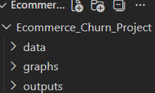

Results and Validation

5.1 Data Preprocessing and ETL Output

The datasets related to e-commerce transactions have been imported and processed before applying data warehousing and mining techniques. In preprocessing stage, missing values from the customers' dataset were handled, and the duplicate entries from the orders' dataset were eliminated. The preprocessed dataset was further integrated and converted into an appropriate format for analysis.
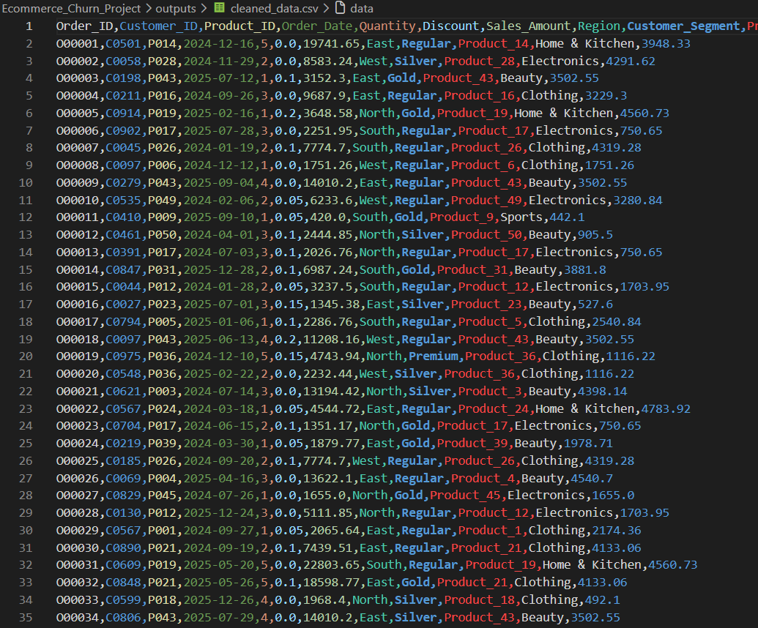

5.2 Data Warehouse Output

Upon the cleaning stage, the clean e-commerce dataset was then arranged in a Data Warehouse layout. The design involves creating a central Fact Sales table alongside the dimension tables for customers, products, and dates.

The created Data Warehouse files are as follows:

    - fact_sales.csv
    - dim_customer.csv
    - dim_product.csv
    - dim_date.csv
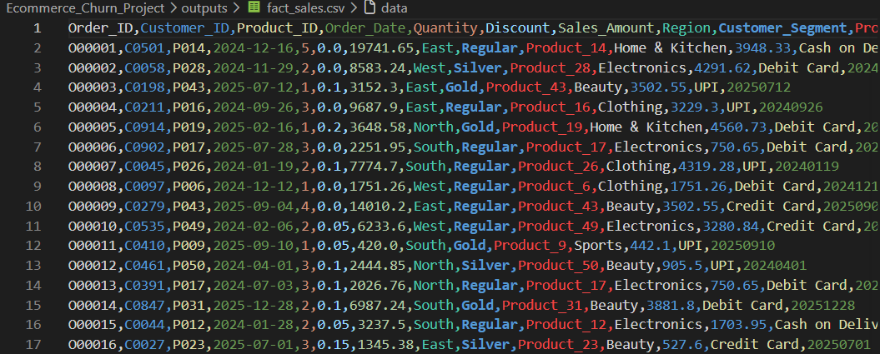
Figure 2: Fact Sales Table of the E-Commerce Data Warehouse
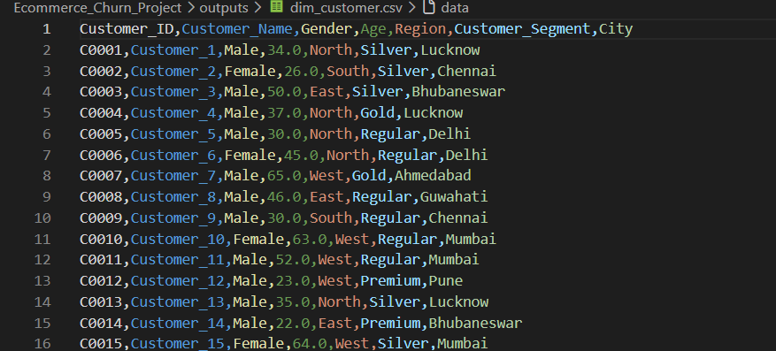
Figure 3: Customer Dimension Table of the Data Warehouse

5.3 OLAP Analysis Results

The OLAP operations were conducted in the E-Commerce Data Warehouse to conduct a sales analysis through various perspectives. The operations that were done include Roll-up, Drill-down, Slice, Dice, and Pivot.

5.3.1 Roll-up

Roll-up operation was performed to perform aggregation of the sales details to a higher summarization level. In this project, the sales details were summarized based on year and month to get monthly sales summaries. It is used to see the trends of sales over time.

5.3.2 Drill-down

The Drill-down operation was conducted to drill down from summarized data to details. The sales information was analyzed based on year, month and order date of sales. This allows detailed view of the sales transactions and analyze the variation at detailed level.

5.3.3 Slice

The Slice operation was performed to select certain portion of the Data Warehouse for detailed analysis. In this project, the sales details for the selected regions were analyzed based on the category of products. It allows analyzing the sales performance of certain region.

5.3.4 Dice

The Dice operation was conducted by selecting the data using multiple conditions. The selected regions and categories of products were used to form small subsets of the dimensions

5.3.5 Pivot

Pivot operation was employed in the reorganization of the multidimensional sales data. The values of sales have been placed in relation to various regions and products, which makes the comparison of sales performance possible from various perspectives.

Validation

The successful use of Roll-up, Drill-down, Slice, Dice, and Pivot operations proves the fact that the Data Warehouse can perform multidimensional analysis. This means that the e-commerce data can be viewed from various perspectives.

5.4 Business Analysis Results

The processed e-commerce data was analysed to identify important sales patterns, customer behaviour, and churn-related insights. The following visualizations were generated from the dataset.

5.4.1 Customer Churn Distribution
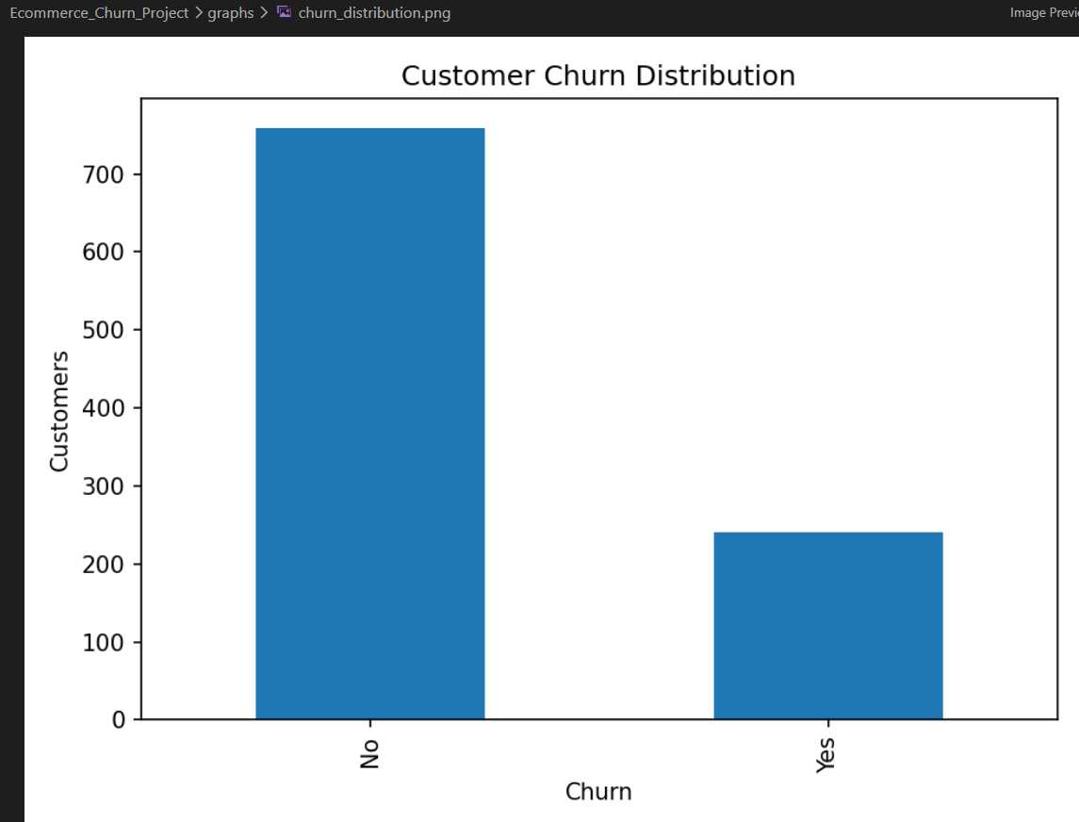

Churn distribution is represented on a graph depicting the number of customers retained by the e-commerce platform and the number of customers churned. Through this analysis, it becomes clear that there is a need to create a robust churn prediction model.

5.4.2 Top Selling Products
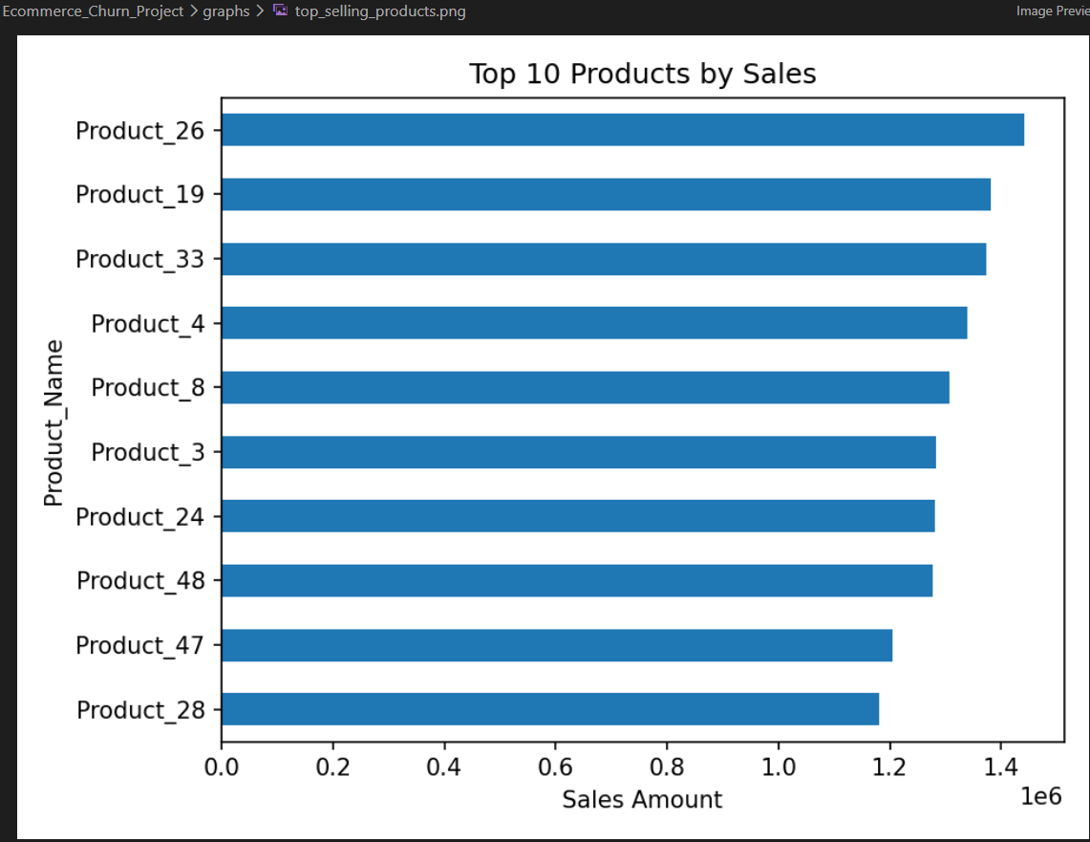

5.4.3 Sales by Region
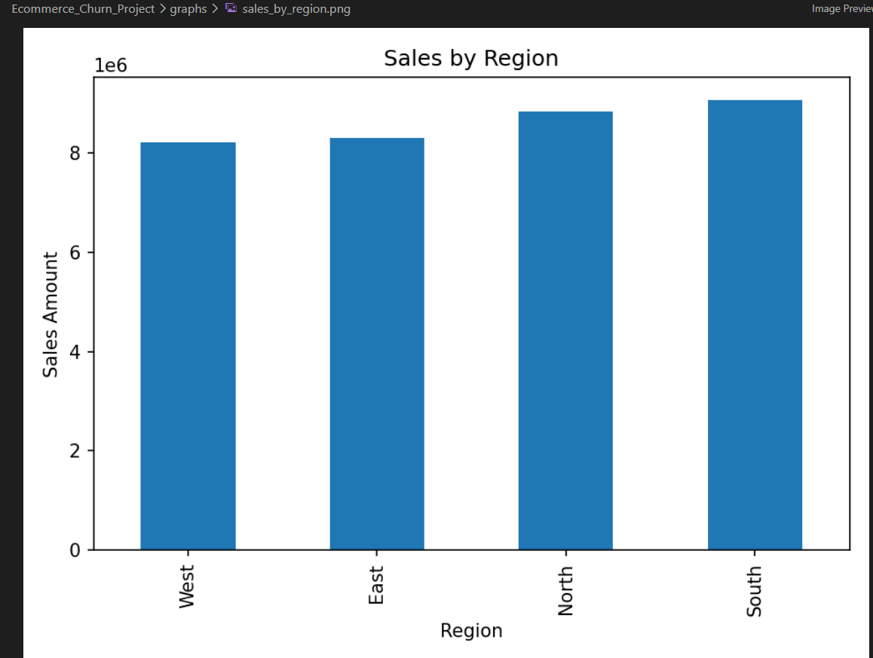

The regional sales analysis compares sales performance across different geographical regions. The visualization helps identify regions with stronger sales performance and can support region-specific marketing and business strategies.

5.4.4 Monthly Sales Trend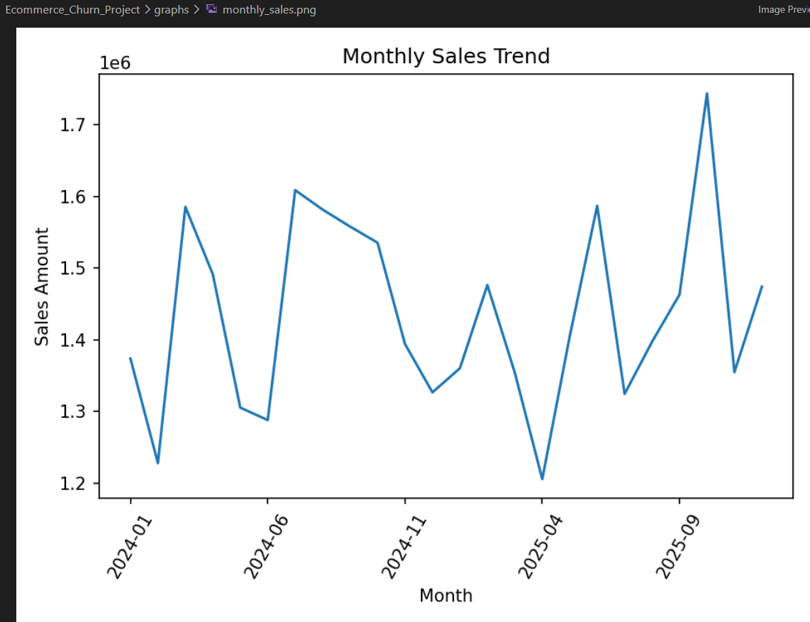

5.4.5 Customer Segment Analysis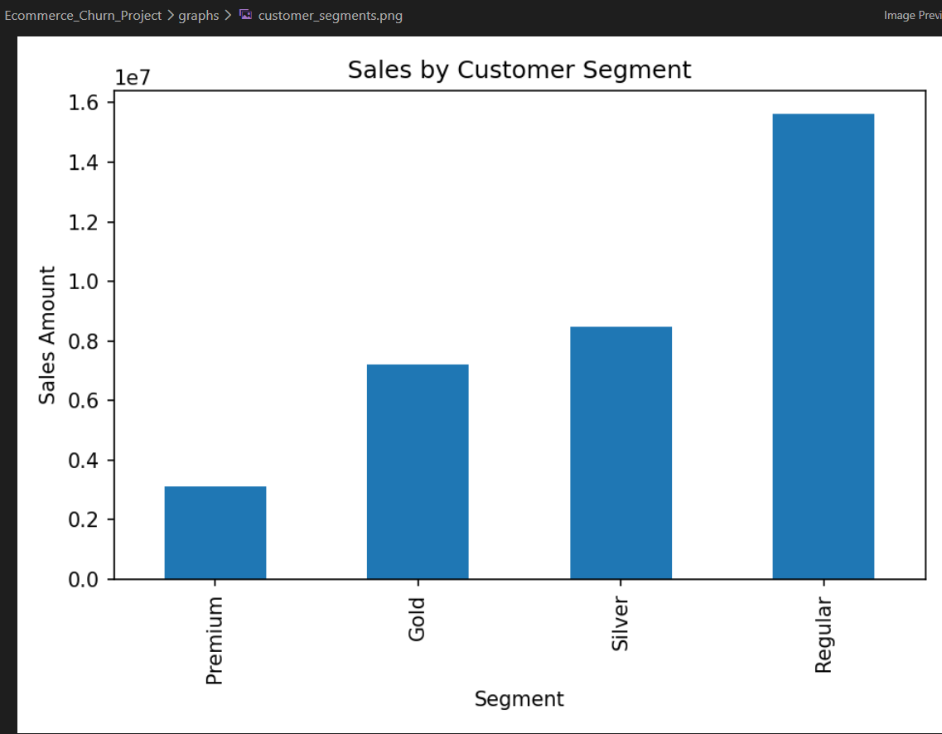
The customer segment analysis compares sales generated by different customer groups. This helps identify valuable customer segments and supports targeted marketing and customer relationship strategies.
5.4.6 High-Value Customers
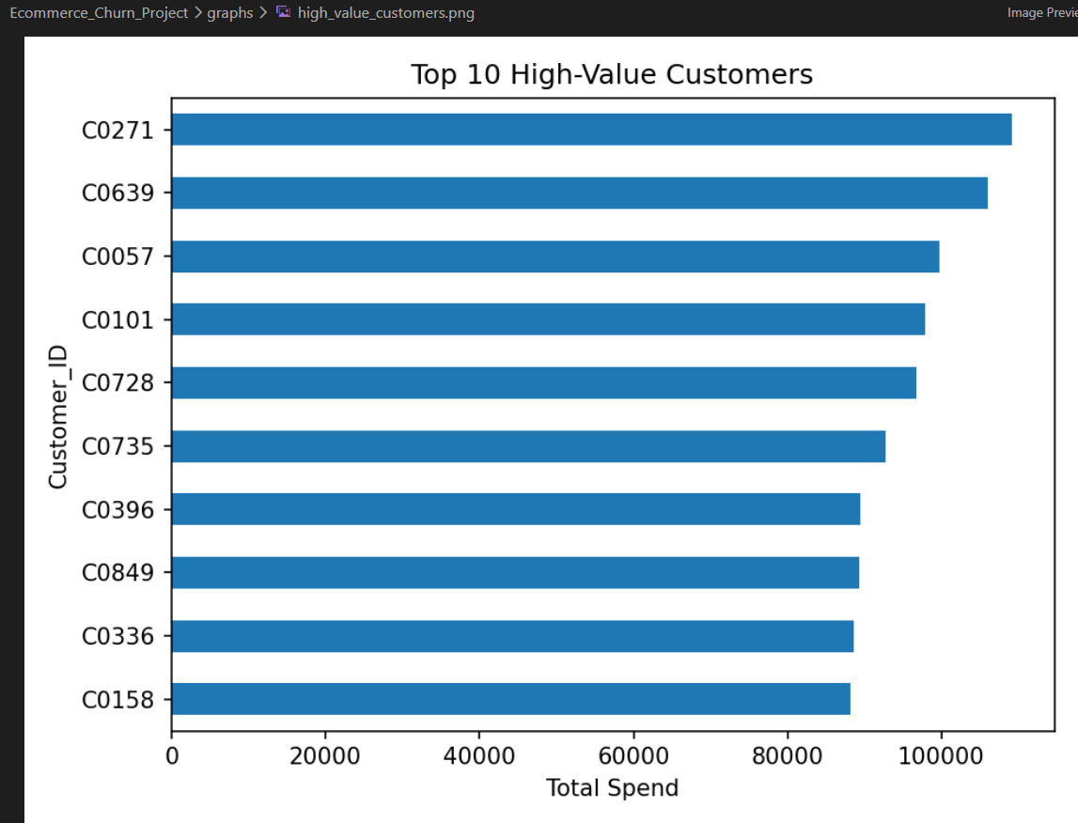
The high-value customer analysis identifies customers with the highest total spending. These customers are important to the business, and understanding their behaviour can help improve customer retention and loyalty strategies.

5.5 Results of Customer Churn Prediction

Customer churn prediction was conducted by applying three classifiers:

- Decision tree
- Naive bayes
- Support vector machine (SVM)

These were tested on the basis of accuracy, precision, recall, and f1 score.
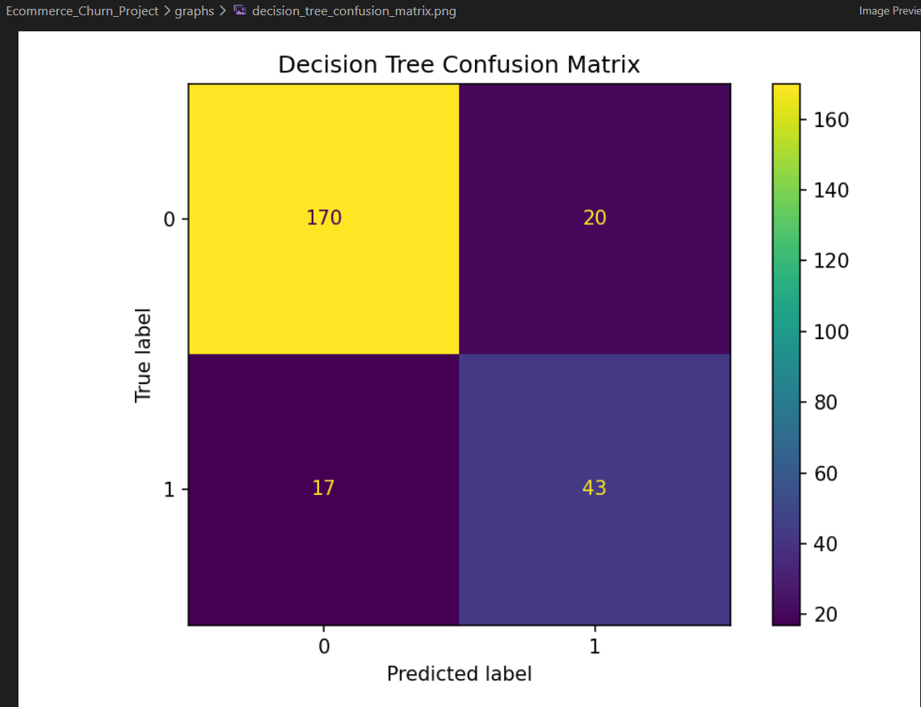

5.5.2 Naïve Bayes Results
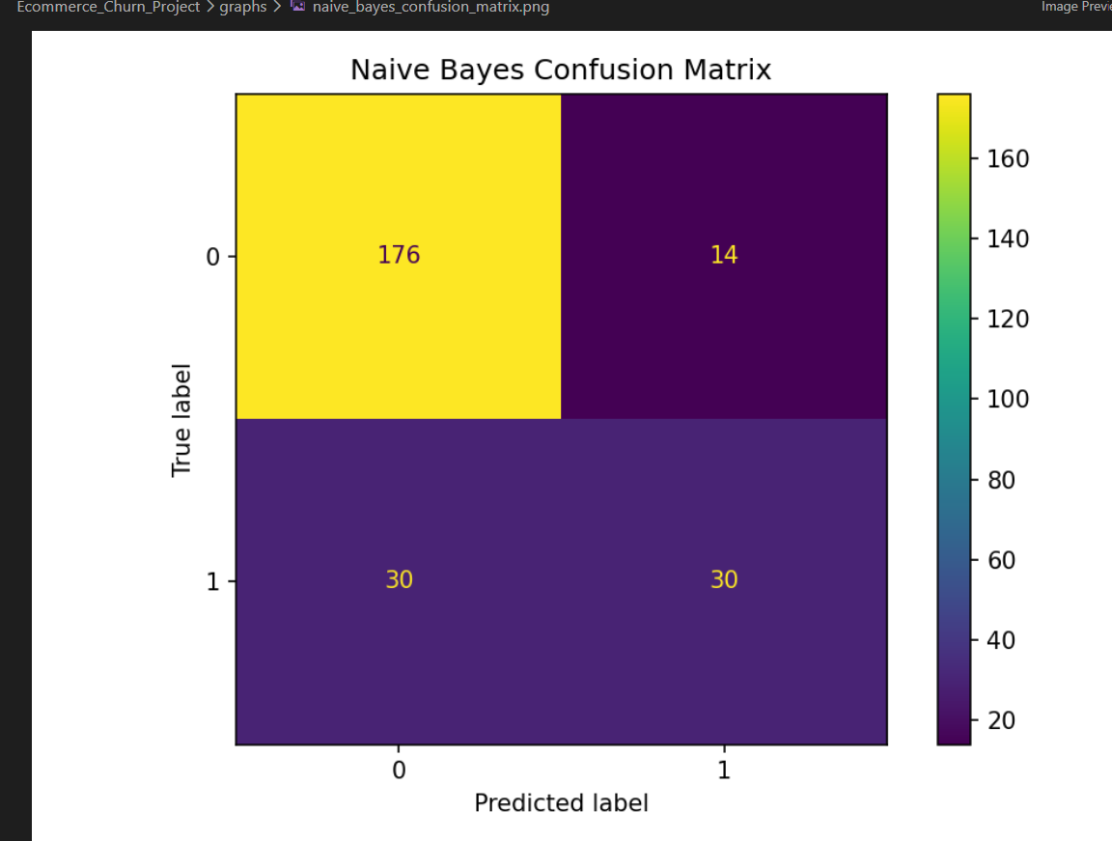
The Naïve Bayes model was implemented for Customer Churn Prediction and produced the following results:
- Accuracy: 82.40%
- Precision: 68.18%
- Recall: 50.00%
- F1-score: 57.69%
The model achieved reasonable accuracy; however, its Recall and F1-score were lower than those of the Decision Tree model.

5.5.3 Support Vector Machine (SVM) Results
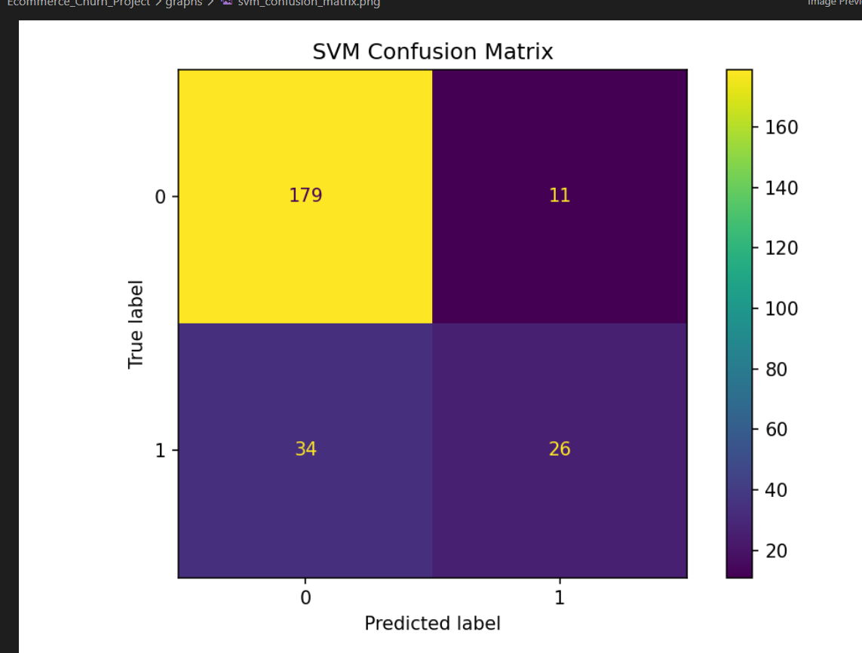

The three classification models were successfully implemented and evaluated using standard performance metrics. The results show that each model can predict customer churn; however, their performance differs, particularly in Recall and F1-score.

5.6 Model Comparison and Final Validation

The performance of the three Customer Churn Prediction models was compared using Accuracy, Precision, Recall, and F1-score.
Model | Accuracy | Precision | Recall | F1-Score
Decision Tree | 85.20% | 68.25% | 71.67% | 69.92%
Naïve Bayes | 82.40% | 68.18% | 50.00% | 57.69%
SVM | 82.00% | 70.27% | 43.33% | 53.61%

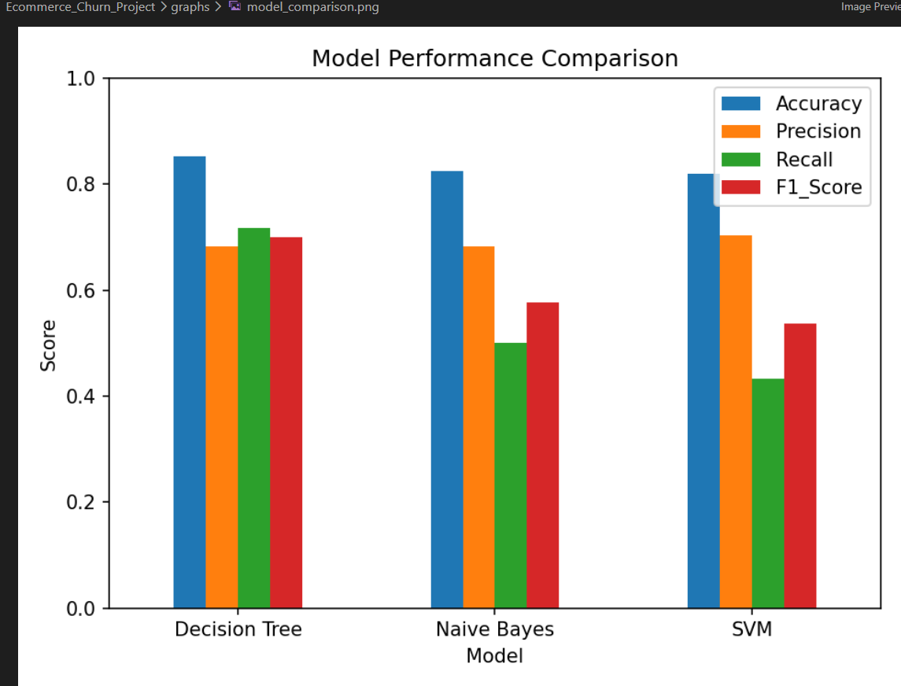

Result and Validation

- The experimental results demonstrate that the Decision Tree model outperformed other two models in all three categories of evaluation metrics. It attained the best Accuracy (85.20%), Recall (71.67%), and F1-score (69.92%).
- Even though the SVM outperformed the Decision Tree in terms of Precision with 70.27% score, it was noticeably weaker in Recall.
- The Naïve Bayes model provided a good overall performance but was inferior to the Decision Tree model by Recall and F1-score.
- Therefore, based on the above-mentioned evaluation metrics, the Decision Tree was chosen as the most appropriate model for the Customer Churn Prediction System.
Final Validation

- The implementation of the proposed system successfully included:
- Creation of a cleaned and integrated e-commerce database.
- Data Warehouse fact and dimensional tables.
- OLAP analysis by Roll-up, Drill-down, Slice, Dice, and Pivot operations.
- Visualization of the business analysis results.
- Customer Churn Prediction by means of three classification models.
- Comparison of models' performance by Accuracy, Precision, Recall, and F1-score.
- Thus, the results proved that the proposed system integrates Data Warehousing and Data Mining

Analysis and Engineering Decision
Results derived from the implementation have been analyzed to check the efficacy of the suggested E-Commerce Data Warehouse and Customer Churn Prediction System.
Analysis of Results
The Data Warehouse effectively structured the processed e-commerce data into fact tables and dimension tables. Such structure facilitated multidimensional analysis and the use of OLAP operations such as Roll-up, Drill-down, Slice, Dice, and Pivot.
The business analysis visualizations helped understand the performance of products, regional sales analysis, monthly sales analysis, segmentation of customers, key customers, and customer churn. The results presented above highlight the utility of data integration in the process of business decision-making.
In case of Customer Churn Prediction, the following three classification algorithms have been tested: Decision Tree, Naïve Bayes, and SVM. The results showed that:
- Decision Tree performed best in terms of Accuracy, which reached 85.20%.
- It also demonstrated the best Recall (71.67%) and F1-score (69.92%).
- SVM performed best in terms of Precision (70.27%), although it had relatively poor Recall (43.33%).
- Naïve Bayes showed Accuracy of 82.40%, but its F1-score was relatively low compared to that of the Decision Tree.

Broader Considerations

The suggested E-Commerce Data Warehouse and Customer Churn Prediction System can offer valuable business insights; however, there is also a need to think about other things, like privacy, fairness, ethical use of data and making responsible decisions.

Privacy and Data Security

Customer data can be personal and behavioral. This is why only data needed for analysis should be gathered and used. Customer data should be kept safely and access should be available to authorized users only.

Fairness

It can happen that machine learning models will give biased outcomes due to bias in the training dataset. This is why it is necessary to monitor the dataset and the model predictions in order to make sure that certain customer segments are not treated unfairly.

Ethical Use of Customer Data

Customer churn predictions should be used to enhance customer experience and retention strategies. The system should not be used to discriminate customers and to automate harmful decisions without appropriate human involvement.

Sustainability

Decision-making based on data can also help firms manage their inventory and operations better. Analysis of the demand could minimize wastage of stock and other resources.

Conclusion

The system should be used in an ethical manner by making sure that:

    - Customer privacy is protected.
    - Data is managed safely.
    - Model predictions are not biased.
    - Customer data is handled ethically.
    - Business decisions are made by people.

Conclusion

The developed E-Commerce Data Warehouse and Customer Churn Prediction system is an excellent example of the application of Data Warehousing and Data Mining for business analysis and decision making.
The e-commerce data was prepared, combined and organized into Data Warehouse tables containing fact and dimension tables. OLAP functions including Roll-up, Drill-down, Slice, Dice and Pivot provided the capability of multidimensional analysis of the sales data.
The obtained visualizations offered valuable information about the customer churn, top-sold products, the best regions regarding sales, the monthly trend of sales, the customer segments, and the most valuable customers.
Regarding Customer Churn Prediction, Decision Tree, Naïve Bayes and Support Vector Machine (SVM) methods have been developed and tested. As a result of the experiments, the Decision Tree model demonstrated the highest quality being the best regarding Accuracy, Recall, and F1-score.
Therefore, this work proves the usefulness of the combination of Data Warehousing and Data Mining techniques to turn raw data into valuable insights, make decisions and to identify the customers requiring retention strategies.

Student Reflection

- In this way, through this assignment, we got practical exposure in using the knowledge of Data Warehousing and Data Mining in a practical problem in e-commerce.
- The significance of data preprocessing like handling the missing values, duplication in data records, and proper data formatting was clear through this assignment. Furthermore, through this, we got an idea about an ETL process and data warehousing process that can be used to integrate the data from different sources.
- By performing the OLAP operations like Roll-up, Drill-down, Slice, Dice, and Pivot operations, we got the practical exposure in analyzing multidimensional data and finding out the business insights from it.
- Furthermore, by performing customer churn prediction by using the algorithms like Decision Tree, Naïve Bayes, and SVM, we got practical exposure in implementing and comparing various machine learning classification algorithms. Evaluation of these models by considering their accuracy, precision, recall, and F1-score showed us that a model is selected based on its performance on overall metrics.

Overall, through this assignment, we got practical knowledge of Python, data preprocessing, Data Warehousing, OLAP analysis, data visualization, and machine learning.

References

- Yu, Xiaobing, Shunsheng Guo, Jun Guo, and Xiaorong Huang. "An extended support vector machine forecasting framework for customer churn in e-commerce." Expert Systems with Applications 38, no. 3 (2011): 1425-1430.
- Zeinali, Mohammad, Leila Ramezani Asli, and Mohammad Amin Khalili. "Integrating Business Intelligence and CRM Systems With a Machine Learning Approach for Predictive Customer Retention in E‐Commerce." The Scientific World Journal 2026, no. 1 (2026): 1946904.
- Javaherihaghighi, Sara, and Oluwafemi Oloruntoba. "Advanced Database Management and Data Mining for Optimizing Supervised E-Commerce Customer Behavior Prediction." International Journal of Computer Applications Technology and Research 10, no. 12 (2021): 279-292.
- Gopal, Priya, and Nazri Bin MohdNawi. "A Survey on Customer Churn Prediction using Machine Learning and data mining Techniques in E-commerce." In 2021 IEEE Asia-Pacific Conference on Computer Science and Data Engineering (CSDE), pp. 1-8. IEEE, 2021.
- Hasan, Md Sakibul, Md Abubokor Siam, Md Abdul Ahad, Mohammad Nazmul Hossain, Mehedi Hasan Ridoy, MD Nazmul Shakir Rabbi, Arat Hossain, and Tanaya Jakir. "Predictive analytics for customer retention: Machine learning models to analyze and mitigate churn in e-commerce platforms." Journal of Business and Management Studies 6, no. 4 (2024): 304-320.
- Matuszelański, Kamil, and Katarzyna Kopczewska. "Customer churn in retail e-commerce business: Spatial and machine learning approach." Journal of Theoretical and Applied Electronic Commerce Research 17, no. 1 (2022): 165-198.
- Shobana, Jayakumar, Ch Gangadhar, Rakesh Kumar Arora, P. N. Renjith, J. Bamini, and Yugendra devidas Chincholkar. "E-commerce customer churn prevention using machine learning-based business intelligence strategy." Measurement: Sensors 27 (2023): 100728

